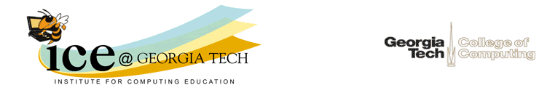

Dear Parents of [Name],

Your daughter's score on the PSAT shows that she could excel in a Computer Science Advanced Placement course. She can use computing to help people, to solve problems, and to be creative. Advanced Placement courses give high school students the chance to earn college credit and/or placement. AP Computer Science A and CS Principles both count as a fourth science for graduation from Georgia High Schools and as a science for entry into Georgia universities.

The United States Department of Labor predicts computing jobs to be among the fastest growing through 2020. They expect there to be over 1.4 million jobs in the U. S. in this field by 2020, but only expect U. S. colleges and universities to graduate enough people to fill less than half of those jobs. Students who graduate with a computer science degree have the highest starting salary of any undergraduate degree.

Computers are crucial to our way of life. They have changed the way we communicate, work, and play. Many of the breakthroughs in medicine are due to computers (like MRIs and CAT scans). Much of advances in Biology required computing. Your daughter could be part of an exciting and rewarding field. See http://dotdiva.org/ for stories from young women in computing.

Even if your daughter isn't thinking of a career in computing an AP CS class can help her. Many fields will require her to take a computer science class in college, especially any science or math fields. At Georgia Tech, all students must pass a course in computer science or place out with a 4 or 5 on the AP CS A exam! Women with prior programming experience are 4 times more likely to succeed in introductory computing classes. Georgia Tech offers Rise Up 4 CS to help female students pass the AP CSA or CSP exams. If you are interested in Rise Up for 2018-2019 please fill out the survey at https://www.surveymonkey.com/r/RiseUP1819Int.

Thank You,

Barbara Ericson
Director, Computing Outreach
College of Computing
Georgia Institute of Technology

